**Hong Kong Institute of Vocational Education (LWL)**

**Department of Information and Communications Technology**

**Human Computer Interaction & GUI Programming (ITP4506)**

**E-commerce website**

**System Document**

**(2016/2017)**

|  |  |  |  |
| --- | --- | --- | --- |
| **Student ID** | **Name** | **Contribution** | **Signature** |
| 150308433 | Lau Ka Po | 50% |  |
| 150198910 | Wong Lap Wang | 50% |  |

Table of Contents

Introduction 3

User Analysis 3

User characteristics 3

**Techniques for observing and listening to users** 4

**Environment Analysis** 4

**Recruiting Users** 4

**Task Analysis (HTA)** 4

Web Design Concepts 5

References 7

# Introduction

Our team received an order to make a website. The website goals are buying and selling of products or services. In this document, we will show you our user analysis and web design concepts.

# User Analysis

User characteristics

**IVE student in school**

**Learning Style:**

* Watch media

**Tool preferences:**

* Search functions what they want

**Physical differences:**

* need user friendly interface

**Cultural differences:**

* High education background
* Can read Chinese and English

**Knowledge of job:**

* Use computer frequently

**Application familiarity:**

* A computer expert

**Techniques for observing and listening to users**

In this part, we are using Think aloud and Online surveys to observing the student. Because school inside much students can accept the interview, but we afraid only use aloud online surveys will miss some students in the class. So, we use these two techniques to observing IVE students.

**Environment Analysis**

In school, not enough computers to use. Some student may use their cell phone. (need bigger buttons and easy UI)

**Recruiting Users**

We will post notice or ask a school society to announce our website.

**Task Analysis (HTA)**

1. In order to buy product form the website
2. go to website
3. find the required computer

2.1 access website catalogue

2.2 access the search screen

2.3 enter search criteria

2.4 show required product

3. add product to shopping cart

4. login

5. checkout shopping cart

Plan 0:

do 1-3-4-5.

If product not in main page, do 2-3-4-5.

Plan 3:

Do 3,5.

If is user, do 3-4-5

# Web Design Concepts

this is our website overview.

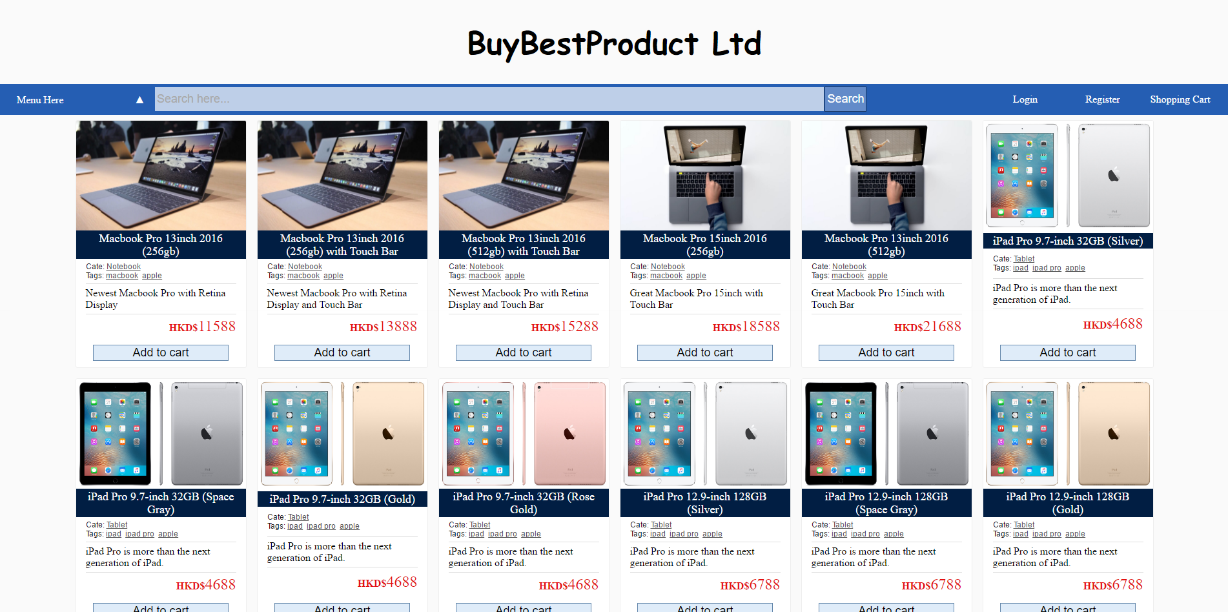

A0.

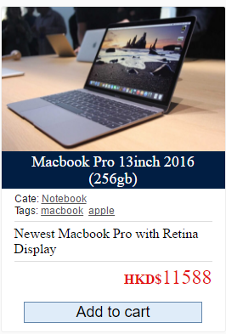

A1.

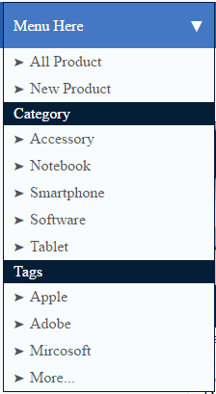

A2.



A3



A4

|  |  |
| --- | --- |
| Design Principles | Description |
| Mental Model | **A1. Use product name and product picture, makes people can see the product and just click.** |
| Affordance | **A3. User will mouse over the Menu Here and want it to show up the menu.** |
| Content Organization | **Chronological A2.**  **Task-Oriented A4** |
| Visual Organization | **Alignment: group related contents along flow of lines A0** |
| Navigation | **Database A0** |

# References

**Website product image from following website:**

1. Macbook pro and earphone/headphone image form http://www.apple.com

2. iPad image form => http://computershowcase.umich.edu/

3. Asus https://www.asus.com/hk/Notebooks/